Prepositional Phrases as Modifiers

🔹 What Is Prepositional Phrases as Modifiers?
# Source: AI Source: Provided by: [Data Path: Persons Table -> ID Column: 1, Name_En Column: Motasem Essam] -> From: [Chatgpt (GPT‑5 Mini)] on [8/7/2025]
A prepositional phrase is a modifier that begins with a preposition and ends with its object (usually a noun or pronoun). It provides additional information about time, place, direction, manner, cause, or condition in a sentence.

🔸 Structure:
# Source: AI Source: Provided by: [Data Path: Persons Table -> ID Column: 1, Name_En Column: Motasem Essam] -> From: [Chatgpt (GPT‑5 Mini)] on [8/7/2025]
Preposition + Modifier(s) + Object of the Preposition

Example:
- in the morning
- under the bridge
- with great care

🔸 Functions of Prepositional Phrases as Modifiers:
# Source: AI Source: Provided by: [Data Path: Persons Table -> ID Column: 1, Name_En Column: Motasem Essam] -> From: [Chatgpt (GPT‑5 Mini)] on [8/7/2025]
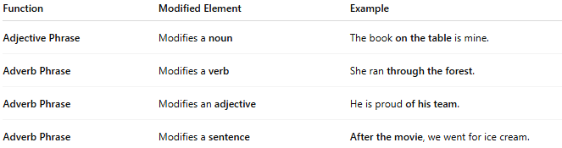
Function | Modified Element | Example
Adjective Phrase | Modifies a noun | The book on the table is mine.
Adverb Phrase | Modifies a verb | She ran through the forest.
Adverb Phrase | Modifies an adjective | He is proud of his team.
Adverb Phrase | Modifies a sentence | After the movie, we went for ice cream.

🔸 Examples in Sentences:
# Source: AI Source: Provided by: [Data Path: Persons Table -> ID Column: 1, Name_En Column: Motasem Essam] -> From: [Chatgpt (GPT‑5 Mini)] on [8/7/2025]
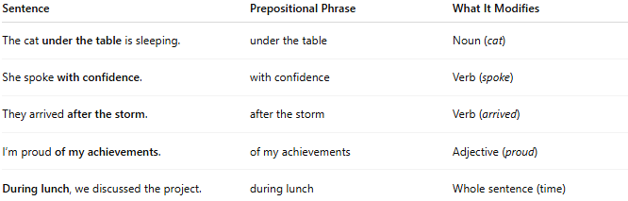
Sentence | Prepositional Phrase | What It Modifies
The cat under the table is sleeping. | under the table | Noun (cat)
She spoke with confidence. | with confidence | Verb (spoke)
They arrived after the storm. | after the storm | Verb (arrived)
I’m proud of my achievements. | of my achievements | Adjective (proud)
During lunch, we discussed the project. | during lunch | Whole sentence (time)

